MCAA Working Group Bridging Science and Business

Logo | Logo name
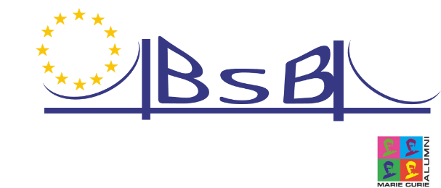 | Logo BSB 1 - Bridge
 | Logo BSB 2 - Person
 | Logo BSB 3 - BSB
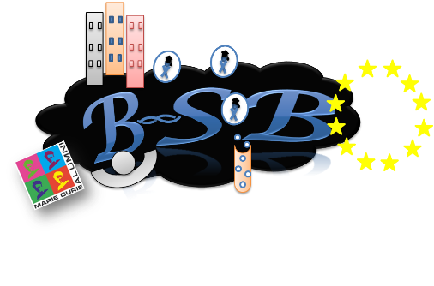 | Logo BSB 4 – BSB Cloud
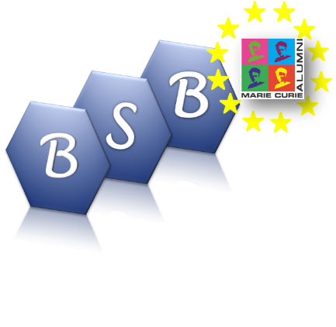 | Logo BSB 5 - Hexagons

